# INTERNSHIP PROJECT REPORT

**Project Title**

# Stock Price Prediction Using ML

Submitted By

### Miss. Hrituja Sambhaji Desai

Under the Guidance of

**Sushank Dahiwadkar Sir**

# Table of Contents

|  |  |  |
| --- | --- | --- |
| Sr No. | Contents | Page No |
| 1. | Abstract/Project Summary | 3 |
| 2. | Technologies Used | 4 |
| 3. | Algorithms Used | 5 |
| 4. | Components or Modules of the Project | 6 |
| 5. | Component Diagram | 7 |
| 6. | Project Algorithm Steps | 8 |
| 7. | Comparison of all the algorithms tested | 10 |
| 8. | Output Screenshot | 12 |
| 9. | GitHub link of the project | 13 |
| 10. | Future Scope | 14 |

1. **Abstract / Project Summary**

This project aims to develop an accurate and reliable predictive model for forecasting Tesla stock prices using Python. Leveraging historical stock data and various machine learning techniques, the project will implement regression algorithms and time-series analysis to uncover patterns and trends in Tesla's stock behavior. Features such as historical prices, trading volumes, and market indicators will be used to train the model. The effectiveness of different algorithms, including but not limited to linear regression, support vector machines, and recurrent neural networks, will be evaluated to determine the most suitable approach for accurate predictions. The project's ultimate goal is to provide investors and financial analysts with a robust tool for anticipating Tesla stock movements, aiding in informed decision-making and risk management in the dynamic stock market environment.

# Technologies Used

### 1.Kaggle – For downloading the dataset 2.Python

1. Libraries Used:
   * Pandas
   * Matplotlib
   * Seaborn
   * Scikit-learn
   * Data Preprocessing and Analysis:
     + Pandas: For data manipulation and analysis.
     + Seaborn and Matplotlib: For data visualization
     + Scikit-learn: For preprocessing (StandardScaler), model selection (train_test_split), and various machine learning

algorithm Naïve Bayes Classification.

### Model Evaludation:

* + Scikit-learn: For metrics such as accuracy_score.

# Algorithms Used

The choice of the algorithm for Tesla stock price prediction would depend on the characteristics of the data and the nature of the problem. Here are some algorithms commonly used in stock price prediction projects:

1. *Linear Regression:* A simple algorithm for modeling the relationship between historical stock prices and relevant features. It assumes a linear relationship and is easy to interpret.

2. *Support Vector Machines (SVM):* Effective for both regression and classification tasks, SVM seeks to find a hyperplane that best separates data points, aiming to predict future stock prices.

3. *Random Forest:* An ensemble learning method that builds multiple decision trees to improve accuracy and reduce overfitting. It's effective for handling complex relationships in data.

4*Long Short-Term Memory (LSTM):* A type of recurrent neural network (RNN) suitable for sequence prediction tasks, like time-series forecasting. LSTMs can capture long-term dependencies in data.

# Components/Modules of the Project

1. *Data Collection:*

- Retrieving historical stock price data for Tesla from financial data sources or APIs.

- Gathering additional relevant data, such as trading volumes, market indicators, or news sentiment, to enrich the dataset.

2. *Data Preprocessing:*

- Cleaning and handling missing data.

- Feature engineering to create relevant input features for the predictive model.

- Normalizing or scaling data to ensure consistent ranges for numerical features.

3. *Exploratory Data Analysis (EDA):*

- Visualizing and analyzing the distribution of stock prices and features.

- Identifying patterns, trends, and potential outliers in the data.

4. *Model Development:*

- Implementing and training predictive models, such as linear regression, support vector machines, random forest, LSTM, or other selected algorithms.

- Tuning hyperparameters to optimize model performance.

5. *Evaluation Metrics:*

- Defining metrics to evaluate the accuracy and performance of the predictive models, such as Mean Absolute Error (MAE), Root Mean Squared Error (RMSE), or others.

# Component Diagram

Model Development

Evaluation Metrics

Model Evaluation

Data Analysis

Data Input

|  |  |  |
| --- | --- | --- |
|  | Data Preprocessing |  |

1. **Project Algorithm Steps**

**1. **Data Collection:\*\***

**- Retrieve historical stock price data for Tesla from financial data sources or APIs.**

**- Gather additional relevant data, such as trading volumes, market indicators, or news sentiment.**

**2. **Data Preprocessing:\*\***

**- Clean and handle missing data.**

**- Perform feature engineering to create relevant input features for the predictive model.**

**- Normalize or scale data to ensure consistent ranges for numerical features.**

**3. **Exploratory Data Analysis (EDA):\*\***

**- Visualize and analyze the distribution of stock prices and features.**

**- Identify patterns, trends, and potential outliers in the data.**

**4. **Model Development:\*\***

**- Implement and train predictive models, such as linear regression, support vector machines, random forest, LSTM, or other selected algorithms.**

**- Split the dataset into training and testing sets to assess model performance.**

**5. **Evaluation Metrics:\*\***

**- Define metrics to evaluate the accuracy and performance of the predictive models, such as Mean Absolute Error (MAE), Root Mean Squared Error (RMSE), or others.**

**6. **Model Comparison:\*\***

**-** Compare the performance of different algorithms to select the most suitable model for Tesla stock price prediction.

**7. **Hyperparameter Tuning:\*\***

**-** Fine-tune model parameters to optimize predictive accuracy.

**8. **Model Deployment:\*\***

- Integrate the chosen model into a deployable format.

- Set up a mechanism for regularly updating the model with new data.

**9. **User Interface (Optional):\*\***

**-** Create a user-friendly interface for users to input new data and get predictions.

- Visualize predictions and trends.

**10. **Testing and Validation:\*\***

**-** Test the model on out-of-sample data to validate its performance and generalization capabilities.

**11. **Continuous Monitoring and Maintenance:\*\***

**-** Implement a system to monitor the model's performance over time.

- Update the model as needed to adapt to changing market conditions**.**

**12. **Documentation:\*\***

**-** Document the entire project, including data sources, preprocessing steps, model details, and usage instructions.

# Comparison of All the Algorithms Tested

1. **Data Splitting:**
   * Divide the dataset into training and testing sets. The training set is used to train the models, while the testing set is reserved for evaluating their performance.
2. **Algorithm Selection:**
   * Choose a set of algorithms to test, such as Linear Regression, Support Vector Machines (SVM), Random Forest, LSTM, and others.
3. **Model Training:**
   * Train each algorithm on the training dataset using historical stock price data and relevant features.
4. **Prediction:**
   * Use the trained models to make predictions on the testing dataset.
5. **Evaluation Metrics:**
   * Calculate evaluation metrics for each algorithm using the predicted values and the actual stock prices in the testing set. Common metrics include MAE, RMSE, and others.

**6.Comparison:**

* + Compare the performance of each algorithm based on the calculated metrics.
  + Identify which algorithm provides the lowest error rates and the most accurate predictions.

**7.Visualization (Optional):**

* + Visualize the predicted vs. actual stock prices using plots or charts to gain insights into how well each algorithm captures the trends.

**8.Statistical Tests (Optional):**

* + Perform statistical tests, if necessary, to assess whether the performance differences between algorithms are statistically significant.

**9.Fine-Tuning (Optional):**

* + If hyperparameter tuning was performed during the model development phase, consider further refining the parameters of the best-performing algorithm.

**10.Final Model Selection:**

* + Choose the algorithm that demonstrates the best overall performance for predicting Tesla stock prices.

# Output Screenshot

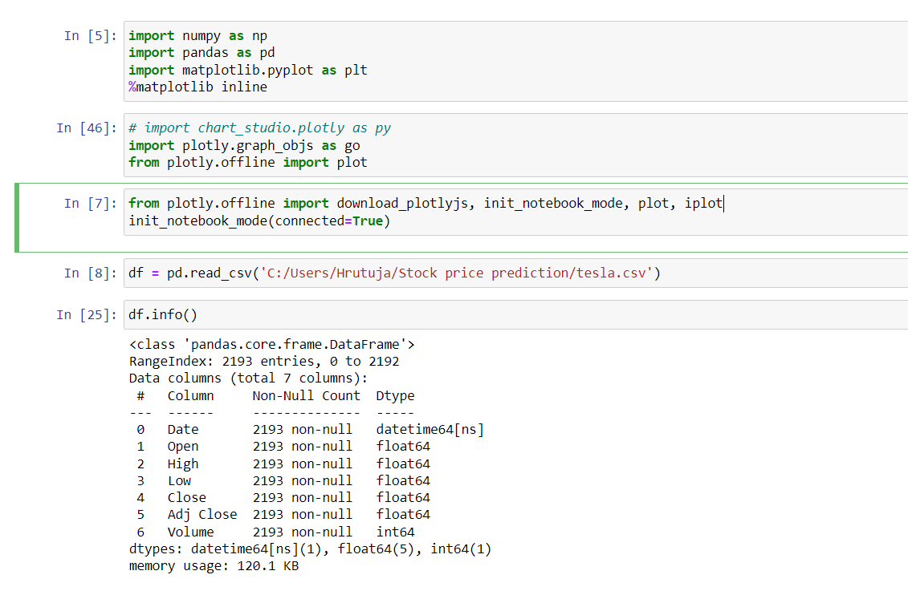

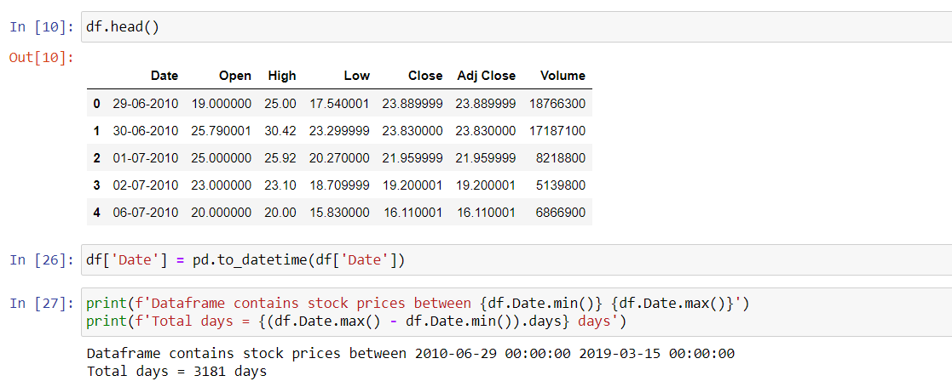

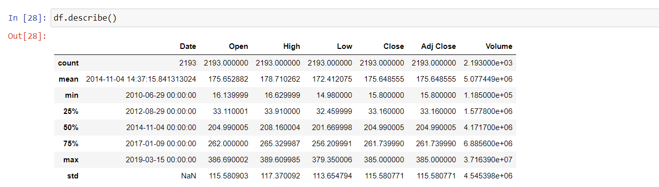

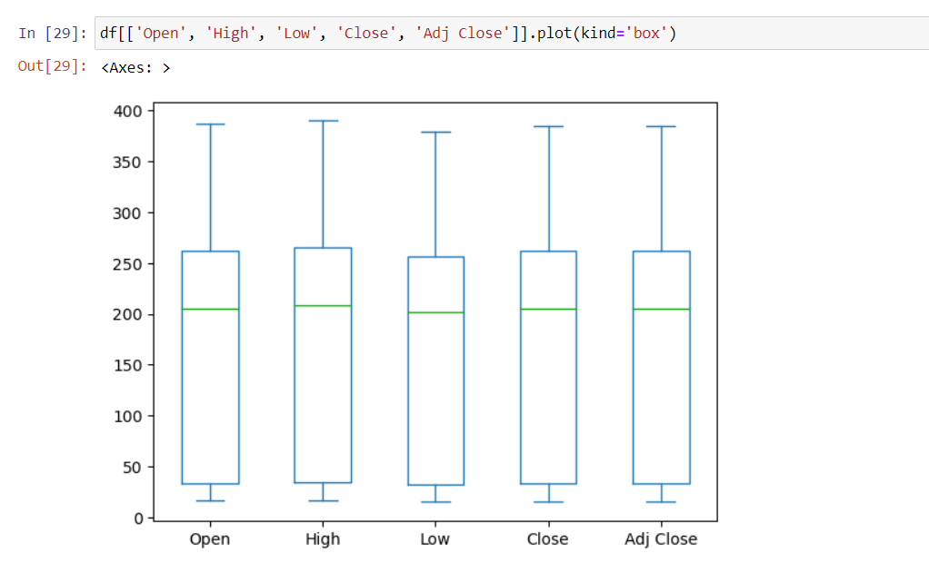

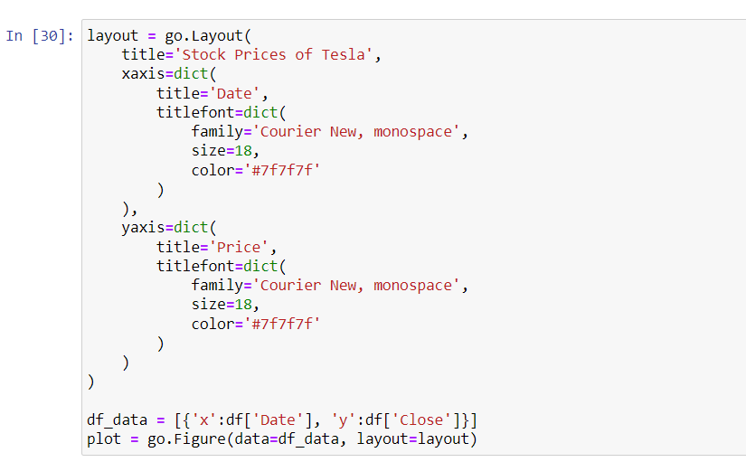

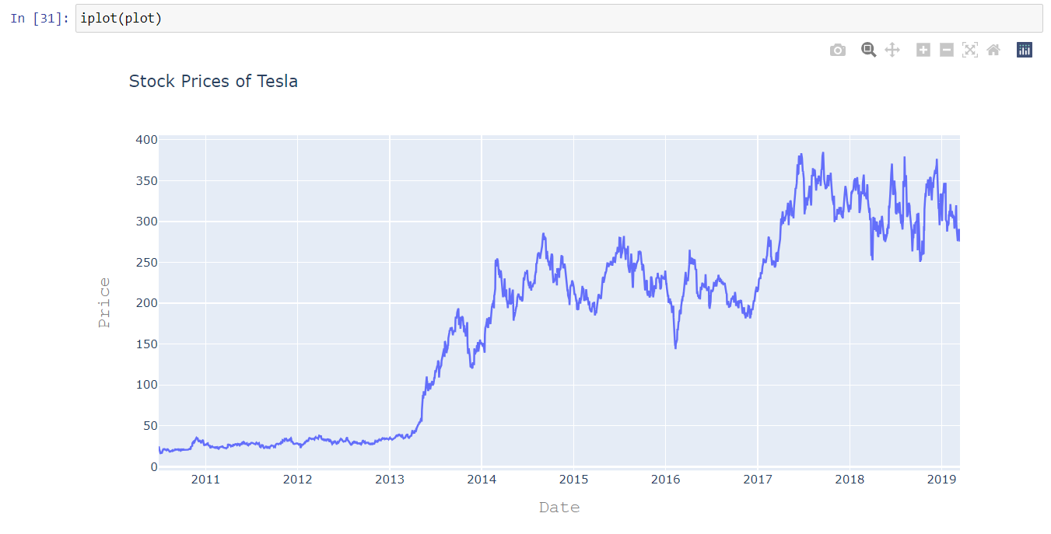

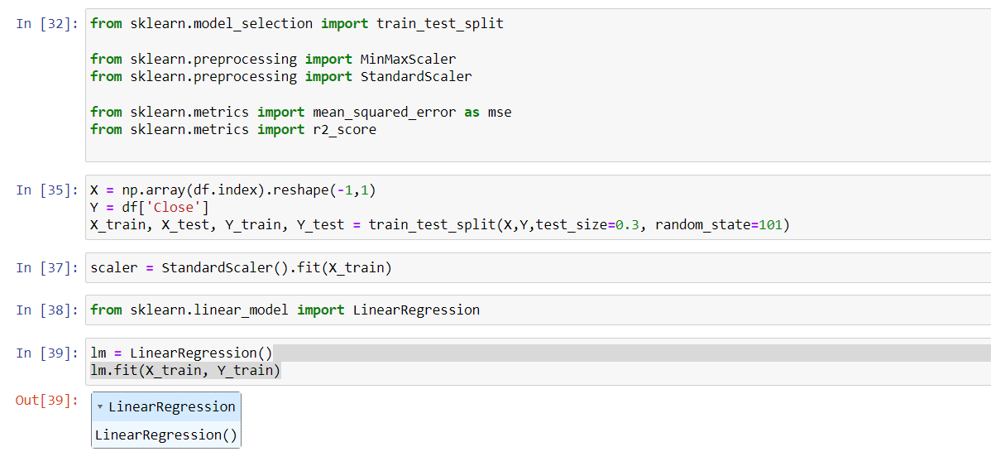

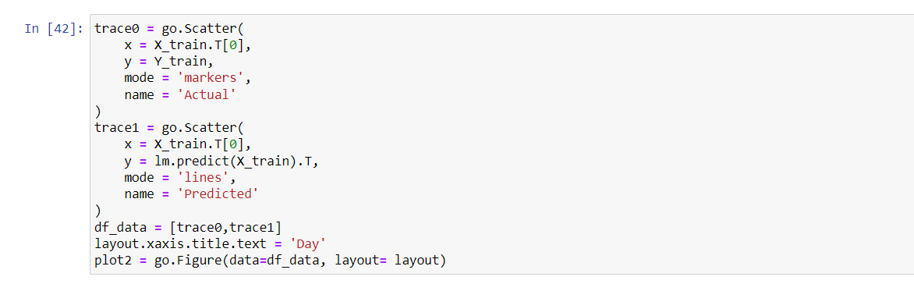

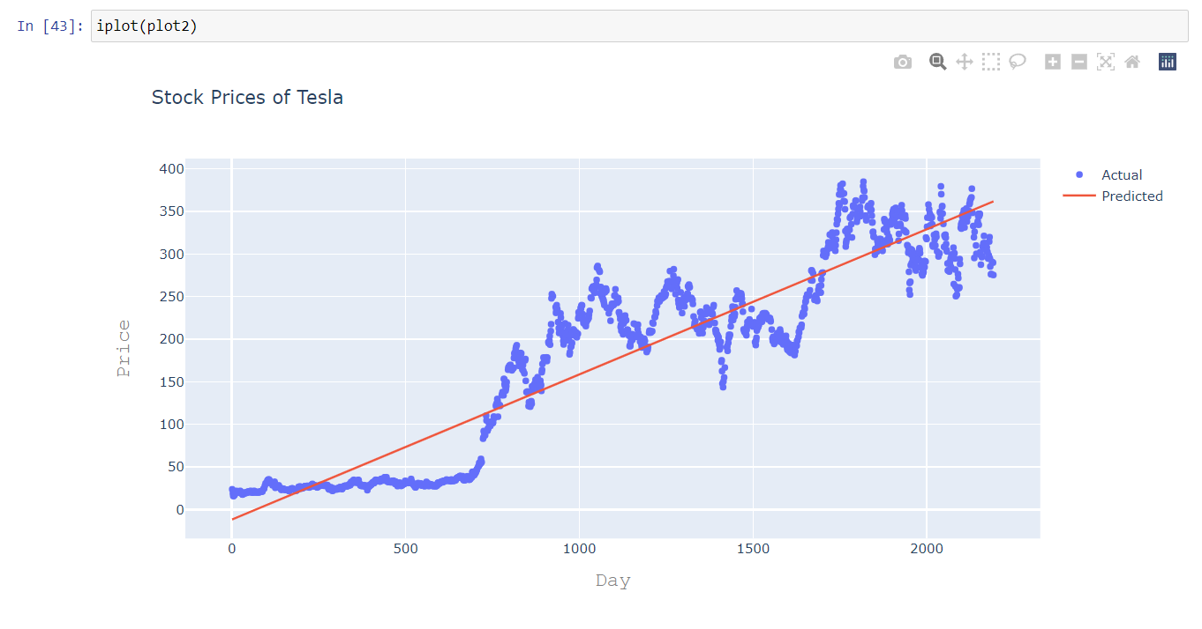

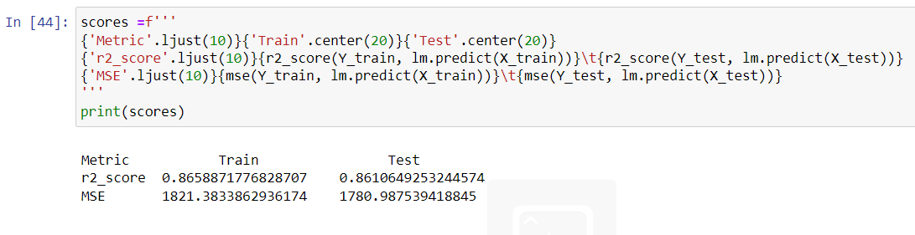

**GitHub Link of the Project**

# Future Scope

The Tesla stock price prediction project has several potential avenues for future exploration and enhancement. Here are some future scope considerations:

1. **Feature Engineering:**

- Explore additional features that may impact stock prices, such as macroeconomic indicators, geopolitical events, or changes in regulatory policies.

2. **Ensemble Models:**

- Investigate the effectiveness of ensemble models, combining predictions from multiple algorithms for improved accuracy and robustness.

3. **Deep Learning Architectures:**

- Experiment with more complex deep learning architectures, such as advanced recurrent neural networks (RNNs) or transformer models, to capture intricate patterns in time-series data.

4. **Transfer Learning:**

- Explore transfer learning techniques, leveraging pre-trained models on financial data or related domains to enhance the model's performance.

5. **Real-Time Prediction:**

- Develop a real-time prediction system to provide up-to-the-minute forecasts as new data becomes available.

6. **Sentiment Analysis:**

- Integrate sentiment analysis from news articles, social media, or other sources to capture market sentiment and assess its impact on stock prices.

7. **Optimization Strategies:**

- Investigate portfolio optimization strategies that leverage the stock price predictions to construct diversified and risk-managed investment portfolios.

8. **Reinforcement Learning:**

- Explore reinforcement learning techniques to develop trading strategies that adapt and learn from changing market conditions.

9. **User Feedback Integration:**

- Incorporate user feedback and interaction data to enhance the model's adaptability and user satisfaction.

10. **Cross-Market Analysis:**

- Extend the analysis to consider the impact of global markets and external economic factors on Tesla stock prices.

11. **Interpretability and Explainability:**

- Focus on improving the interpretability of the model's predictions to provide more transparent insights into the factors influencing stock price movements.

12. **Mobile Applications:**

- Develop mobile applications or web-based platforms to make the predictions and insights accessible to a wider audience.